Presteigne Memorial Hall Health and Safety Policy

**1 General Statement**

Key Health, Safety and Environmental Policy Objectives:

* To ensure that Memorial Hall operations are undertaken in accordance with best practice procedures which reflect compliance with current and up to date statutory safety, health and environmental legislation.
* To provide the users of the Memorial Hall with ‘best practice’ information, procedures and equipment.
* To ensure that the Memorial Hall and its surrounding areas do not cause risk to the health and safety of users and to others who may be affected by its use.
* To ensure that the use of the Memorial Hall and its surrounding areas do not cause risk to the local or wider environment through poor environmental control or practices.
* To continually improve the health and safety policy at regular intervals or at other times where events such as significant health and safety incidents or the introduction of new or updated legislation dictates.

**2 Key Statutory Duties Compliance:**

We shall do all that is reasonably practicable to implement our legal duties under all relevant statutory provisions and in particular those provisions outlined in the Health and Safety at Work Act 1974 and the Management of Health and Safety at Work Regulations 1999.

In particular, as members of the Memorial Hall Committee we will:

* Provide and maintain equipment that is safe and without risk to health.
* Ensure the safety and absence of risks to health in connection with the use, handling and storage of articles and substances.
* Ensure the maintenance of areas under our control is safe and without risks to health, which includes the provision and maintenance of safe access and egress routes.

**3 Organisation of Health and Safety**

The Presteigne Memorial Hall Board of Trustees has overall responsibility for health and safety at Presteigne Memorial Hall and takes day to day responsibility for the implementation of this policy.

It is the duty of all hirers, users and other visitors to take care of themselves and others who may be affected by their activities and to co-operate with the Board of Trustees in keeping the premises safe and healthy.

It is the responsibility of hirers to ensure that adequate safeguards are in place to protect the well-being of the disabled, children and vulnerable adults.

Should anyone using the hall come across a fault, damage or other situation which might cause injury and cannot be rectified immediately they should inform the Chair or the Bookings Secretary as soon as possible so that the problem can be dealt with.

Where equipment is damaged or otherwise faulty a notice should be placed on it warning that it is not to be used and the Chair or the Bookings Secretary informed as soon as possible.

The following persons have responsibility for specific items:

* First Aid box: Geraldine Fletcher
* Reporting of Accidents: Geraldine Fletcher
* Fire precautions and checks: Russell Fletcher, David Knight, Eva Venny
* Risk Assessment and Inspections: Russell Fletcher
* Information to contractors: Geraldine Fletcher, Russell Fletcher
* Information to hirers: Sarah Chilman, Jack Reynolds
* Insurance: Sam Haden

A plan of the hall is attached showing the location of fuse box, emergency exits and fire doors, and fire extinguishers.

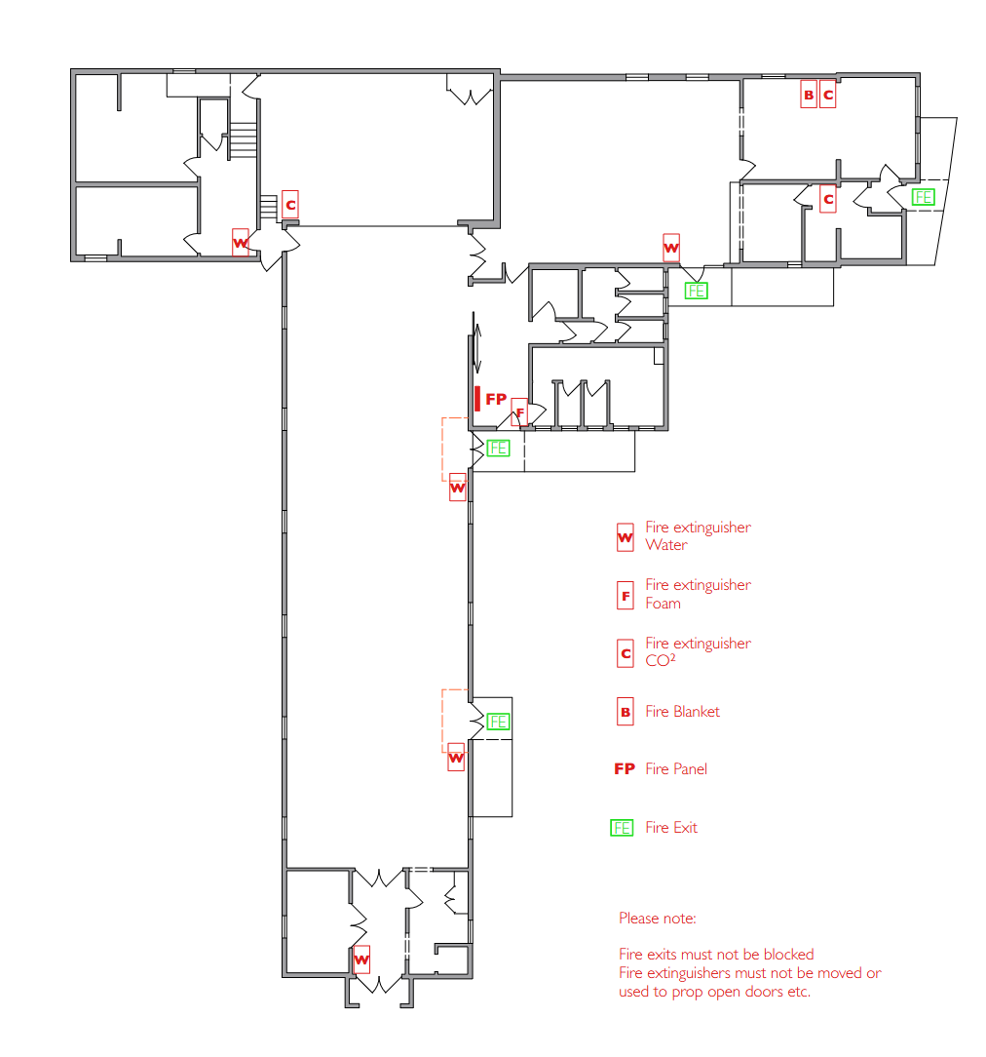

**4 Licences**

Alcohol/premises license:

A PPL PRS Ltd Music Certificate is in place and displayed within Hall on the main display board. Renewal is the responsibility of the Treasurer

**5 Fire Precautions and Checks**

The Management Committee has completed a Fire Risk Assessment in accordance with the Regulatory Reform (Fire Safety) Order 2005.

* Person with responsibility for testing equipment and keeping log book: David Knight, Eva Venny
* Local Fire Brigade Contact: 999 for emergency, Presteigne Fire Station, 03706060699 for non-emergency
* Company hired to maintain and service fire safety equipment:
* Company hired to conduct six month and annual tests of of fire alarm and emergency lighting:

**6 Checking of Equipment, Fittings and Services:**

Weekly: floor, toilets, boiler, accident book, fridges, outside lights, emergency lighting, fire doors, all lights, fire alarm, First Aid box, steps, locks and sockets

Yearly: Fire extinguishers, electrical certificate, gas boilers, PAT testing

**7 Procedure in case of accidents**

* The location of the nearest hospital Accident and Emergency department is Hereford County Hospital or Ludlow Minor Injuries
* In case of emergency the hirer should call 999.
* The location and telephone number for the nearest doctor’s surgery is Lugg View, Presteigne, 01544 267 985
* The First Aid Box and information is located: in the kitchen with the labeled cupboard
* The person responsible for keeping this up to date is: Geraldine Fletcher
* The accident forms are kept in the First Aid kit. These must be completed whenever an accident occurs and the Chair notified.
* Any accidents must be reported to the Chair of the Management Committee.
* The person responsible for completing RIDDOR forms and reporting relevant accidents in accordance with the Reporting of Injuries, Diseases and Dangerous Occurrences Regulations 1995 is: Geraldine Fletcher. RIDDOR Forms at

https://notifications.hse.gov.uk/riddorforms/Default